**Documentation Coastwood Furniture Project**

**By Tarunveer Singh**

**About Project**

User can login to application from this page by providing mailing address and password used for training application. In training application, user must have granted permission to login to monthly application. After login user will be redirected to region page.  
  
User can logout from the application by clicking on the link at top right corner of the page. Also use can edit his/her profile from link which is immediate right to 'welcome' at top right corner of page. User can add/edit/delete region from this page. Input fields are available above the table to add the region. To edit the region, click on the edit link, then it will give options for inline editing. In setting page, users can add/edit/delete the setting information. It further divides into four categories:

Visual Studio .Net 2010, C#.Net, ASP.Net4.0, AJAX, JQuery, MS SQL Server 2008

User can login to application by providing username and password. Clicking on forgot password link will open forgot password dialog. Click on exit menu to close application. After login user can logout from welcome → logout.  
  
User can input username and create new password to login. After login user can change password from welcome → edit profile menu. It will open edit profile dialog.  
  
Meetings section, briefings section, coordination section, referral section.  
  
User can add new customer on this form. Customer menu helps one adding new customer. After saving it will show invoice list for that customer, link to add new invoice, export as excel link, export as pdf link. User can edit customer details, add/edit/delete invoice for that customer. Print invoice report for that customer as excel and pdf.

**Admin**

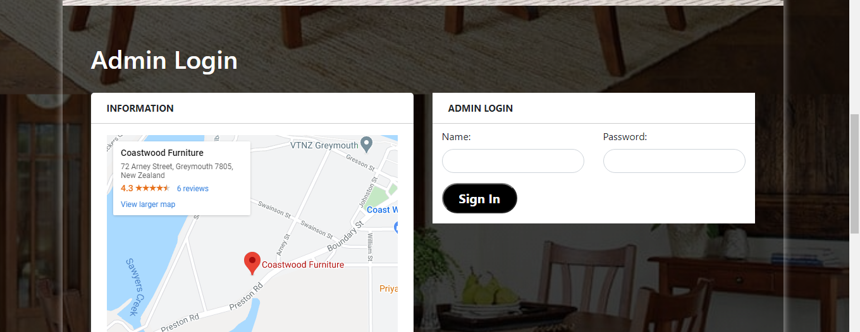

**Name: admin**

**Password: password**

Working area

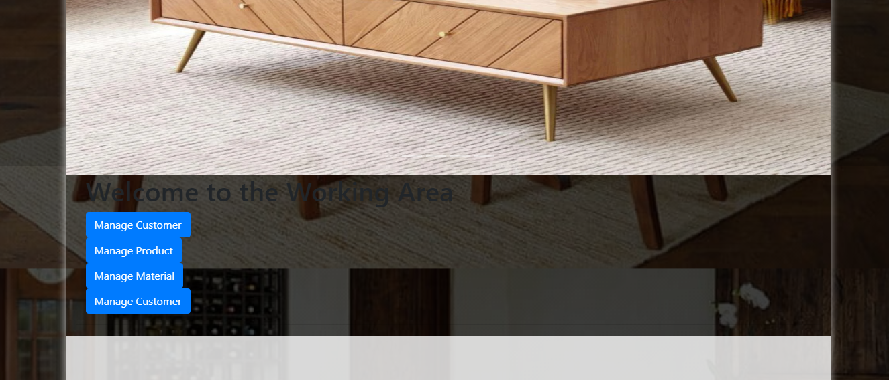

**Manage Customer**

Here you can add Client details , update details and delete the details of the client details

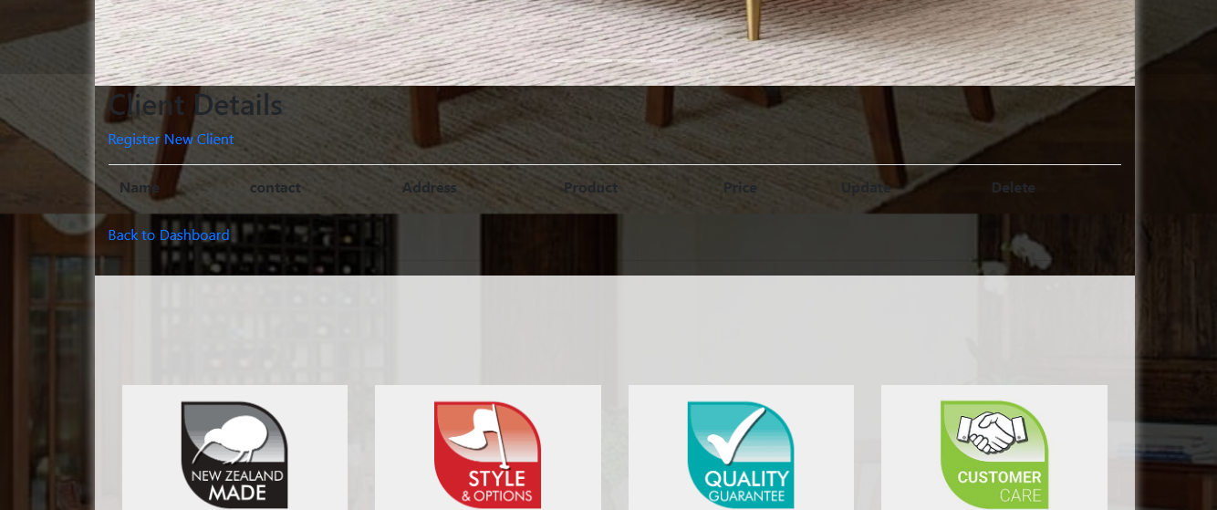

**Manage Client**

Here you can add client details; update details and delete the details of the clients.



**Manage Material**

Here you can add raw material details , update details and delete the details of the raw material

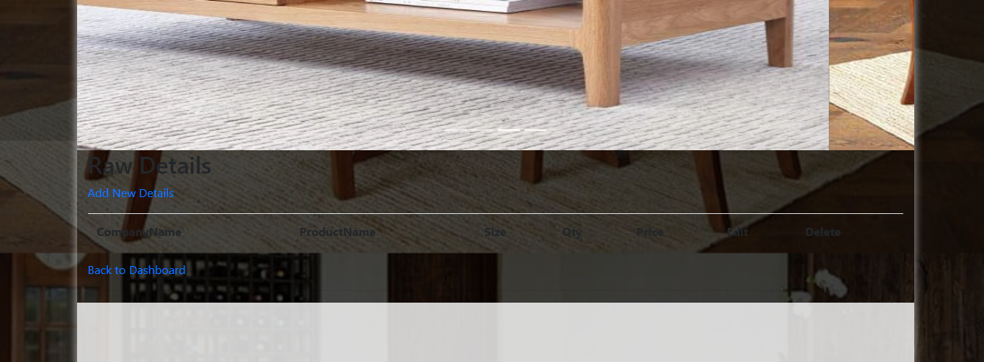

**Manage Customer**

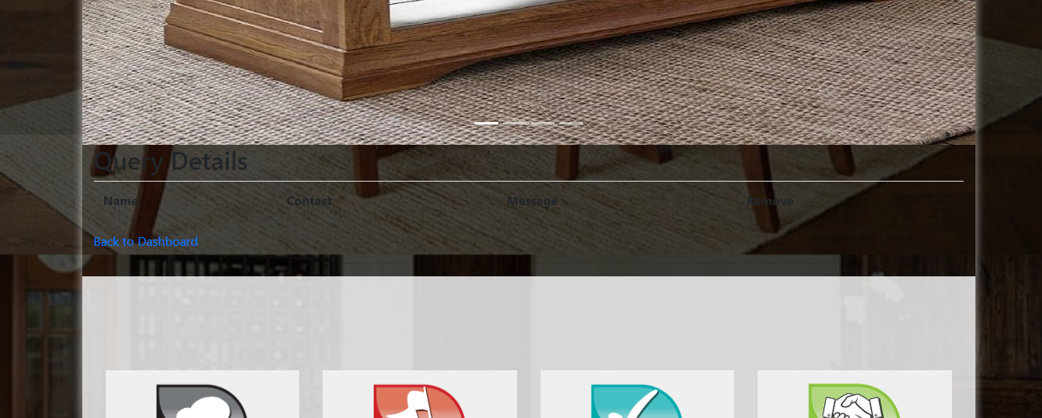

**Index**

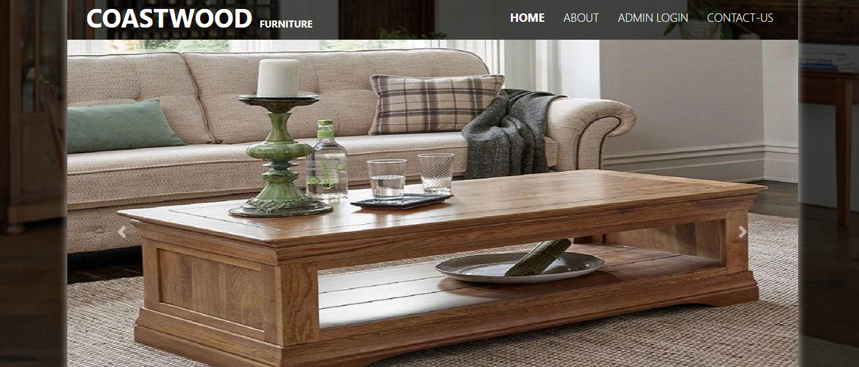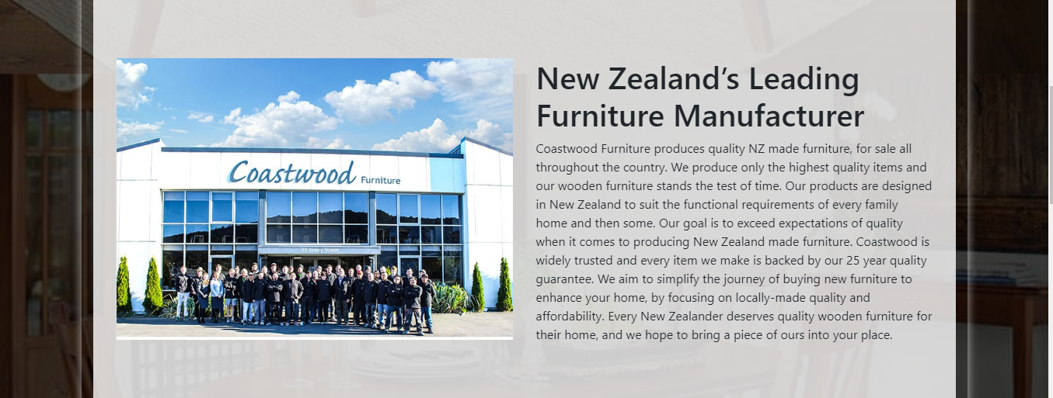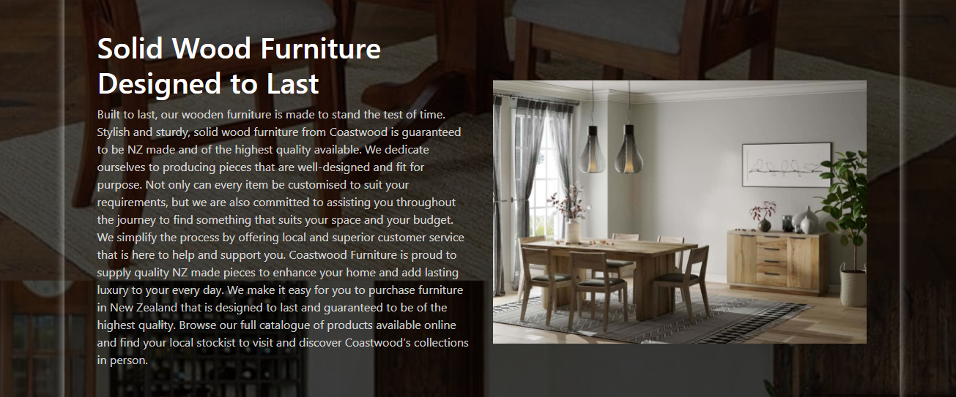

**Contact Us**

